Marketing Funnel & Conversion Performance Analysis
Future Interns – Data Science & Analytics Internship (Task 3)
Submitted By: Monika.D
Internship Program: Future Interns – Data Science & Analytics Internship
Task: Marketing Funnel & Conversion Performance Analysis
Tool Used: Microsoft Power BI
Dataset: Bank Marketing Dataset

1. Introduction
Marketing campaigns play a vital role in converting potential customers into actual customers. Organizations invest significant resources in marketing activities and therefore need to understand how effectively their campaigns generate conversions. The purpose of this project is to analyze customer conversion patterns and identify factors that influence successful campaign outcomes.
This analysis was conducted using Power BI to create an interactive dashboard that visualizes conversion performance across different customer demographics and communication channels. The dashboard provides insights into customer behavior and helps identify opportunities for improving future marketing strategies.

2. Objective
The primary objectives of this project are:
- Analyze the overall marketing funnel performance.
- Calculate the conversion rate achieved by the campaign.
- Identify the communication channels generating the highest conversions.
- Evaluate customer conversions across different job categories.
- Examine conversion trends over different months.
- Analyze conversion performance based on education levels.
- Create an interactive dashboard for dynamic exploration of customer segments.

3. Dataset Overview
The dataset contains customer information collected during a bank marketing campaign. It includes demographic details, communication methods, campaign interactions, and conversion outcomes.
Key Attributes Used:
- Contact Method
- Month
- Job
- Education
- Marital Status
- Housing Loan Status
- Personal Loan Status
- Campaign Outcome (Conversion)
The target variable indicates whether a customer converted after being contacted during the marketing campaign.

4. Tools and Technologies Used
- Microsoft Power BI Desktop
- Power Query
- DAX (Data Analysis Expressions)
- Data Visualization Techniques

5. Data Preparation
Before visualization, the dataset was cleaned and prepared within Power BI.
The following preprocessing steps were performed:
- Imported the dataset into Power BI.
- Verified data quality and structure.
- Checked for missing or inconsistent values.
- Created calculated measures for:
  - Total Contacts
  - Converted Customers
  - Conversion Rate (%)
- Organized categorical variables for dashboard analysis.
DAX Measures Used
Total Contacts
Total Contacts = COUNTROWS('future interns task 3')
Converted Customers
Converted Customers =
CALCULATE(
COUNTROWS('future interns task 3'),
'future interns task 3'[default] = "yes"
)
Conversion Rate
Conversion Rate % =
DIVIDE([Converted Customers],[Total Contacts],0)
Format the Conversion Rate measure as Percentage.

6. Dashboard Development
The dashboard was designed using multiple visualizations to provide a comprehensive overview of marketing campaign performance.

Dashboard Page 1 – Marketing Funnel Overview
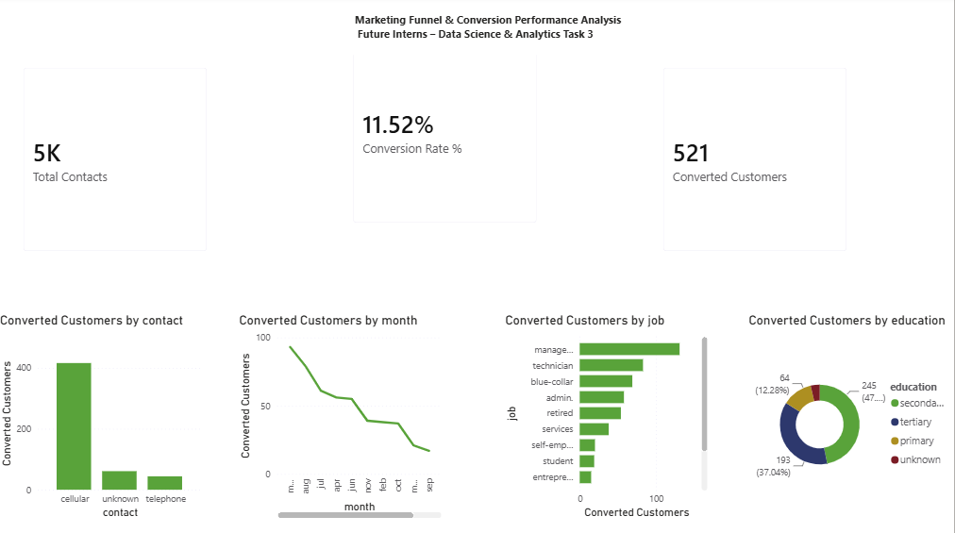
KPI Cards
- Total Contacts: 5K
- Converted Customers: 521
- Conversion Rate: 11.52%
These KPIs provide a quick summary of overall campaign performance.

Converted Customers by Contact Method
A column chart was created to compare conversion counts across communication channels.
Key Insight:
Cellular communication generated the highest number of conversions, significantly outperforming telephone and unknown contact methods.

Converted Customers by Month
A line chart was used to examine monthly conversion trends.
Key Insight:
Conversions were higher during earlier campaign months and gradually decreased toward later months, indicating seasonal variation in customer responsiveness.

Converted Customers by Job
A horizontal bar chart was used to compare conversions across occupational categories.
Key Insight:
Management and technician roles contributed the highest number of conversions, suggesting stronger engagement among professional customer segments.

Converted Customers by Education
A donut chart visualized conversion distribution across education levels.
Key Insight:
Customers with secondary education represented the largest share of conversions, followed by tertiary and primary education groups.

7. Dashboard Page 2 – Interactive Customer Segmentation
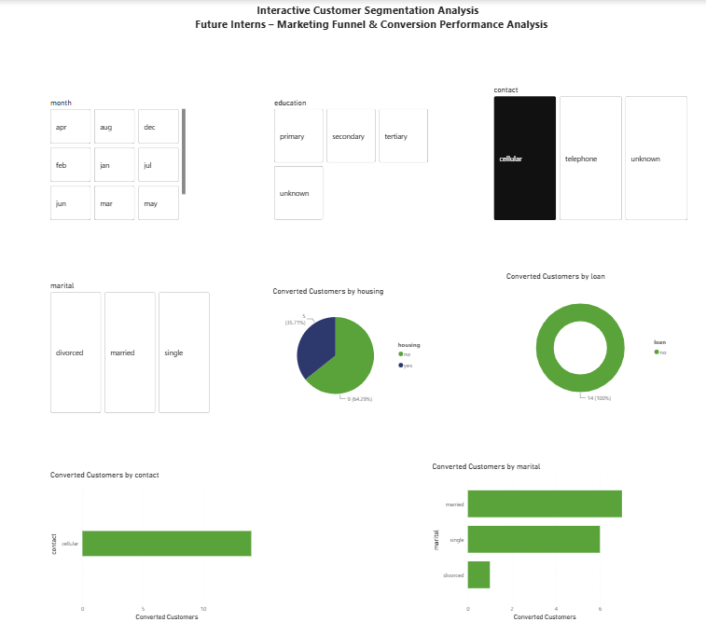
Interactive Filters Included
- Month
- Education
- Contact Method
- Marital Status
Users can dynamically filter dashboard results and explore specific customer groups.

Converted Customers by Housing Loan
A pie chart was used to compare conversion performance based on housing loan status.
Key Insight:
Customers without housing loans demonstrated stronger conversion performance than those with active housing loans.

Converted Customers by Personal Loan
A donut chart analyzed conversion distribution according to personal loan status.
Key Insight:
Most conversions originated from customers who did not have personal loans.

Converted Customers by Contact Method
A bar chart further validated communication channel effectiveness.
Key Insight:
Cellular communication remained the most effective contact method.

Converted Customers by Marital Status
A bar chart was used to analyze conversions among different marital groups.
Key Insight:
Married customers generated the highest number of conversions, followed by single customers.

8. Key Findings
The analysis revealed several important insights:
- The overall campaign conversion rate was 11.52%.
- Cellular communication was the most effective contact method.
- Conversion activity varied significantly across months.
- Customers in management and technician occupations showed stronger conversion performance.
- Secondary education customers represented the largest converting segment.
- Married customers generated more conversions than other marital groups.
- Customers without housing or personal loans exhibited higher conversion levels.

9. Business Recommendations
Based on the findings, the following recommendations are suggested:
- Increase the use of cellular communication channels for future campaigns.
- Focus marketing efforts on high-performing occupational groups such as management and technicians.
- Target customer segments with stronger historical conversion behavior.
- Optimize campaign timing by focusing on months with higher conversion performance.
- Develop personalized marketing strategies based on customer demographics and financial profiles.
- Continuously monitor conversion trends using interactive dashboards.

10. Conclusion
This project successfully analyzed marketing funnel performance using Power BI and provided valuable insights into customer conversion behavior. The interactive dashboard enables efficient exploration of customer segments and campaign outcomes. The findings can support data-driven marketing decisions, improve campaign effectiveness, and increase future conversion rates.
The project demonstrates the practical application of data analytics and business intelligence techniques in evaluating marketing performance and identifying actionable business opportunities.

End of Report

